**Modernizing Waste Management through AI**

**Smart waste collection system:**

**ABSTRACT:**

One of the most challenging aspects of managing any municipality or community is managing the waste generated by consumers, businesses, and the public sector. Managing this waste traditionally was a largely manual process, but artificial intelligence (AI) is starting to be utilized in some communities to remove much of the labor, and therefore costs, involved with managing and processing waste. By incorporating a variety of technologies, including machine learning (ML), deep learning (DL), and computer vision, a number of solutions have emerged that are likely to improve the efficiency and productivity of waste management. One way AI is being utilized is by training waste sorting robots that can be used at garbage dumps. Rather than needing to have workers sort through garbage, these autonomous robots are trained using ML algorithms to identify and process waste based on the type of garbage. The algorithms are trained on images of various types of waste. Using computer vision, the robots can sort through waste and match garbage based on specific characteristics, much in the same way humans might compare pieces of garbage. Most importantly, the machines will continue to learn over time and are more efficient than humans. Intelligent trash bins are fitted with computer vision sensors to identify the type of garbage being thrown inside them. For example, a system developed by Bin uses an ML algorithm to train the system to identify and categorize the type of trash being thrown away, and then the waste is sorted into bins by type. As such, all of the sorting is carried out as the waste is being disposed, eliminating the need to sort through large piles of waste at the waste processing center.

**Introduction:**

During this pandemic, I had joined PH1 Fabrication Works pvt ltd company near to my house as a supervisor. Then my work is to update the work to the head office, maintaining the staff and workers attendance and about the material for the project. So they had done project on waste and garbage recycling vending machine, then I have some personal experience on this project and selected this topic. My idea is that they need to look for industrial automation using smart waste management techniques. This is needed right from proper waste disposal, waste collection, prompt checking to prevent over flow to safely disposing them. Recycling is yet another major innovative step towards reduction of waste and to get back from the used products. Recycling industry is now dominated by dumpster robots which makes the task of sorting and recycling very easy and brings down the human intervention and exposure to waste. Through this we hope to establish the information based on the latest technology which has been proposed and practically implemented with optimization as the future developments. Then I went through some of the articles and gathered the information here.

**Methodology:**

Here we are currently experiencing a fast development of Smart Cities where engineers, urban planners, architects and city managers are joining forces with the goal of boosting up the efficiency of municipal services and increasing benefits and convenience to their communities. The more the waste we generate, the more we waste the resources and initiate hazardous situations for bio life. Waste management is one of the primary problem that the world faces irrespective of the case of developed or developing country. Improper waste management has been proven to be the sole reason for the hazardous air pollution leading to serious health issues like COPD (Chronic Obstructive Pulmonary Disease) and Asthma, for people who have their livelihood close to these Garbage bins. The failure to remove this accumulated garbage is the sole reason for breeding of mosquitoes and houseflies, which is the root cause of fatal diseases like Dengue, Malaria, etc. In this case, efficiency may be related to a wide spectrum of factors such as quality of life, economy, sustainability, or infrastructure management. We describe how an integrated cyber physical system design, based on the combination of different disciplines in engineering, and taking advantage of municipal wireless access networks can lead to smart ways of improving the management of cities. The proposed system lays over the foundation of Geographic Information Systems (GIS), applied graph theory on graph optimization, and machine learning. It consists of an IoT based prototype with sensors measuring the waste volume in trashcans or containers, with the capability of transmitting information to the Internet via a wireless link. This data is used to optimize the management and strategies of waste collection logistics. And using freely available geolocation data of the municipality owned trashcans as Open Data. The simulation covers a period of one month where trashcan filling and waste collection are modelled. his is needed right from proper waste disposal, waste collection, prompt checking to prevent over flow to safely disposing them. Recycling is yet another major innovative step towards reduction of waste and to get back from the used products. Recycling industry is now dominated by dumpster robots which makes the task of sorting and recycling very easy and brings down the human intervention and exposure to waste.

**Dataset:**

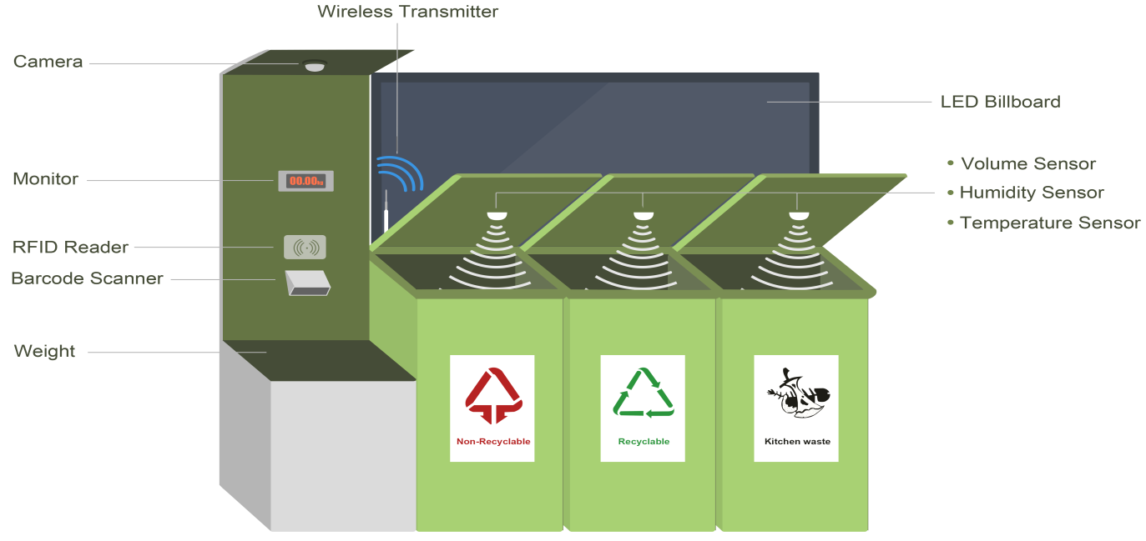

The working was tested with the real data from GIS (Geographic Information Systems) of the streets and trash can locations. The other alternative technology used in the information transmission is using the RFID tags and RFID (RADIO FREQUENCY IDENTIFICATION) readers. It is based on the preliminary radio technology. The RFID tag is the combination of the antenna and the embedded microchip which store an identical serial number to track the object or the person. With the RFID tag, the radio frequency is transmitted over through the Reader’s Antenna. The RFID tag modulated signals is received by the reader. The RFID tag is responsible to store the trash data and transmit it to the RFID reader. The active tags have longer range of service with their own internal battery to support their power consumption. The Passive tags depend on the readers to suffice the operating power and therefore have a lower range of just a few meters. The RFID has the radio frequency transmitted once the reader in switched ON. Once the RFID tag comes near to the reader antenna, the data is received and reverted back to the RFID reader. The most common reader used in the EM-18 and it is a passive tag with the tag ID shifted to Arduino Microcontroller. The Working of the RFID system: The microchip contains a unique ID that integrates the circuitry for the proper functioning of the tag. The internal EEPROM is essential to trace and keep the unique ID. The tag used is passive so the antenna receives the power and the radio frequency signals from the RFID reader. To recognize the RFID tag, the reader sends the data back to the tag. The coil receives the signals in the form of alternating current and passes it to the microchip. The RFID tags and the readers are to be in the same frequency for the communication. The wide range of frequencies is left as the option for optimization and as per the requirements. The low frequency is around 125 kHz and the high frequency is about 13.56 MHz with the ultra-high frequencies varying between the 860 and 960 MHz. Most of the applications are also based on the 2.45 GHz frequency too. The entire system is programmed to send a notification to the server once the trash cans reach a certain level. The RFID reader is interfaced with the microcontroller to enhance the process of verification. As the RFID tag interrupts the RFID reader, the ultrasonic sensor calculates the level of trash filled in the dustbin. Based on the level indicated the cleaning process is initiated. Usually the RFID tag is placed in the trash bin and the RFID reader is placed with the antenna in the truck.

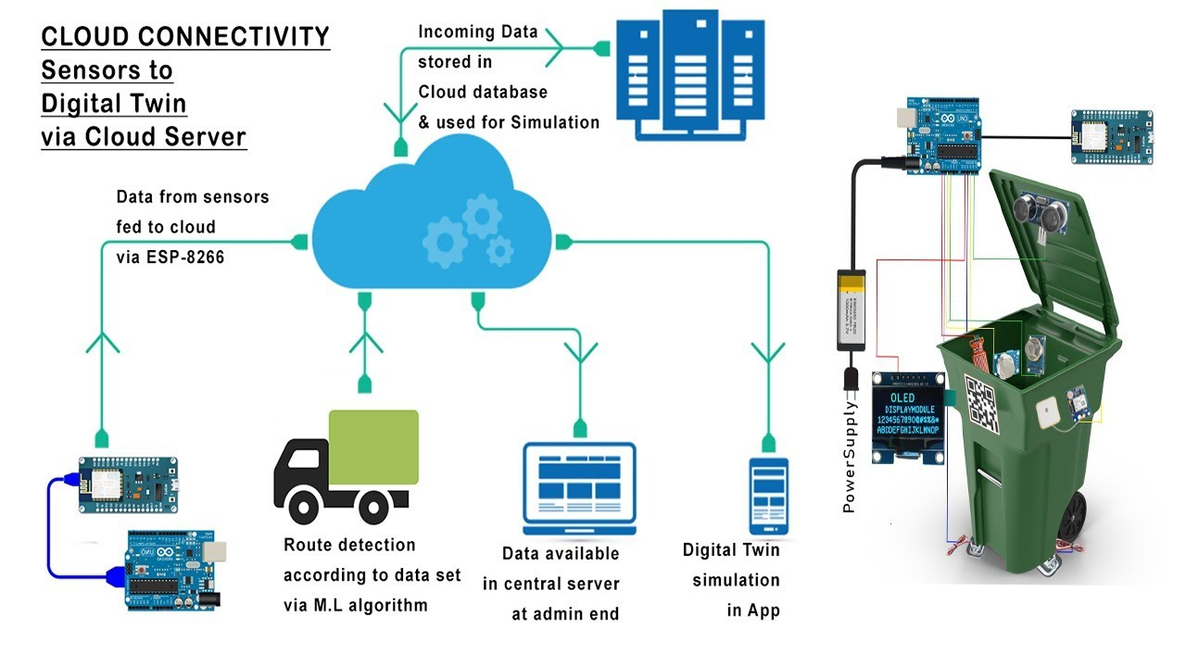

**Details of Analysis:**

**System Function:**

The system is completely based on the indication of waste levels in the trash can by the embedded sensors. The data about the volume is transmitted to the servers over the internet. The collected data after processing is used to optimize and direct the municipality cleaning process. With this automated process, the cleaning team has new routes each day, to visit and clear trash bins based on the need and also ensure that there is no trash left unattended. The end results are a cleaner society with reduced costs and manual efforts. The collected data is used to statistically analyze the rate of filling up of these trash cans.

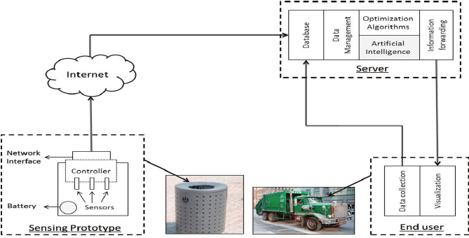

**System Components:**

**Sensors:** The amount of waste is determined by the level of waste collected from the top of the lid. The SONAR technique is used to sense the distance, using Ultrasonic Ranging Module . With an accuracy of 3 mm, this technique can clearly indicate the distance in the range from 2 to 400 cm. The temperature sensors, and weight sensors along with metal detectors are useful for sorting the biodegradable, recyclable and reusable items from the trash cans.

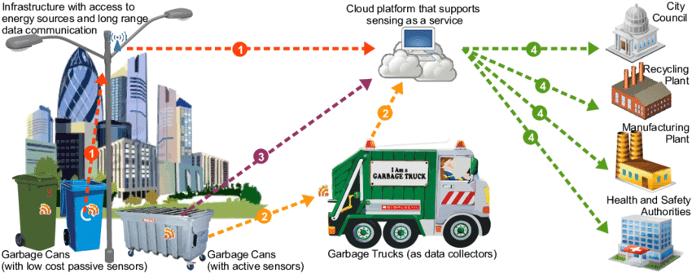

**Microcontroller:** Arduino Uno, based on ATMega328, is used as the decision making microcontroller in this prototype. With an operating voltage at 5 V and optimized power consumption of about 40–50 mA, it is sufficient to collect data and transmit it over the internet. The microcontroller has been chosen based on the parameters like minimal power consumption, memory, processing and the economic cost.

**Access Network Interface:**

Using the WiFi technology, the information from the trash cans can be sent to the servers through internet. One of the methods have implemented the CC3000 Shield with the on-board antenna as it is known to have exceptional coupling with the microcontroller chosen.

**Battery output:**

Since the working of this system is based on a daily report generation, the battery is chosen to facilitate a long duration of use.

**Database:**

The data collected from the trash cans are organized into the data systems, using the software such as MySQL.

**Artificial Intelligence:**

From the data collected, the statistical analysis helps in the determination of the possible rates of filling the trash cans and the appropriate routes to be followed regularly by the cleaning team. Also, the timings of the data collected from trash cans emphasizes on the locations to be given priority during the different times of the day. Some places might see a regular filling of trash cans in the mornings while others in the late nights. Also, there are some locations like the schools, offices, houses which need immediate cleaning compared to open fields with lesser human interaction. So once the artificial intelligence is boosted to the system, the routes are defined and optimized based on the timings and the corresponding need.

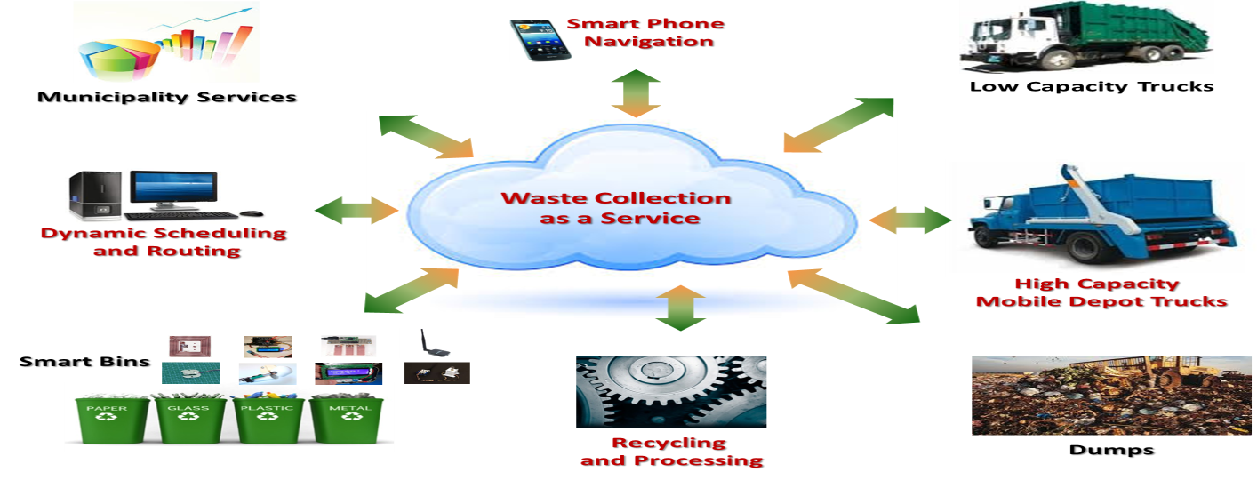

**Optimization techniques:**

With the recorded data, the system uses the artificial intelligence and optimization techniques to reduce the transportation expenditure of costs and time, by directing the best routes to empty the filled trash cans. This is optimized keeping in mind the traffic, and the driving distance and time. The end of the optimization results in a highly efficient route to be followed by the truck drivers, enhanced with the GPS location services.

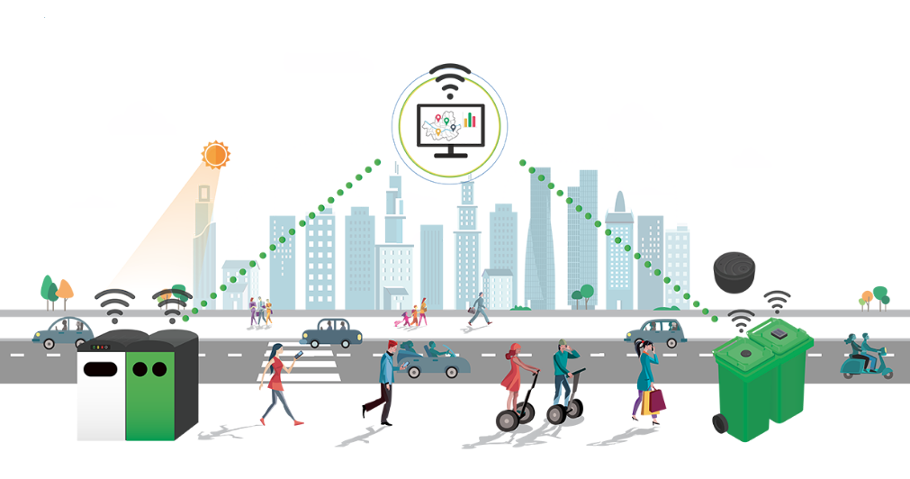

**The Smart Dustbin:**

The cylindrical structure is associated with a piston that is useful for compression of the garbage. The trash can plate is attached to the cylinder and the leaf switch is to be suspended upside down through the side hole. The leaf switch level is placed at a point lower than the maximum level. This is essential for the precautionary measures of the garbage overflow, in cases of fault from the cleaning team. The compressing plate can reach down to press the switch. Once the threshold level is reached, the garbage is prevented to be dumped inside the trash can in order to avoid overflow.

**Artificial Intelligence Based Sorting Techniques:**

The sorting of waste materials is highly essential to give way to recycling. There are multiple ways to sort the waste materials which significantly determine the cost efficiency and the output levels. The Source segregation involves the separation of recyclable materials into the corresponding different criteria, right at waste production site. It is considered as the best mode of waste segregation by manual self-awareness schemes. The source segregation mode of waste processing show the possibility of waste recovery has the potential to more than 25% with steadily increasing positives. On the other hand, for the fully mixed waste to be processed is labor intensive conventionally. Automating this process is an excellent use of the technology and skill in order to prevent the human interference and the corresponding vulnerability to respiratory and skin prone diseases. These lie on the higher end of financial investments with a waste recovery rate of mere 15%. The machine learning induction algorithm that we propose to use here is capable of changing the conventional methods and efficiency rates, to a better output. The machine learning induction algorithm is capable of adapting to the changing situations and incorporating new conditions and discoveries with those preloaded findings. One of the major advantages of this lies in the possibility and potential to combine even unrelated and discrete sensor data into the process of decision making. With time, the performance of the inductive system can exceed and go beyond that of an expert and super intelligent system which might be constrained by the hard coded and less acquired knowledge base.

The figure depicts a conceptual understanding of the prototype proposed as the Waste segregation system, its components and the way they interact and communicate with each other. The Sensor interrogator and the database assimilator consists of the PC-Type computers which is handled by a single computer capable of performing the tasks independently. The configuration illustrates the mode of learning by the system. The machine is trained to detect glass, metal articles and plastic, using a variety of possible shapes, deformation levels, sizes, color, and different levels of contamination. Each substance is made to pass through a systematically placed array of unique sensors. Their corresponding responses are recorded and a combined database is established which possesses the accumulated sensor data and the interpreted information. All the containers will now be analyzed and checked using the AIMS. The performance parameters set by the user will determine the comparison and use of different induction algorithms. A machine learning algorithm is designed to learn the ways to perform a given task based on the preloaded data and preset examples. This is referred to as example driven learning. It has the capability of learning on its own through feedback it takes from the environment based on its direct interaction. This is known to be the goal driven aspect of machine learning. We would like to discuss the example driven learning that requires the user to set the list of possible scenarios as examples during the training of the machine code. The examples presented to the machine is usually a vector consisting of input variables along with the output variables. The learning algorithm is designed to produce a function or the model that is capable of mapping the input variables to the output variables. The physical attributes in this waste segregation model is the specifications of the container, such as the size, color, acoustic features and the optical density. This acts as the input variable to the model. Other possible input variables that can be used to describe the container is the details regarding the objects origin and the date of trash collection. These act as a direct link to the system output. The output is the determination of the waste segregation bins to which each of the waste object is to be sent. After feeding the machine with adequate number of examples, the example driven learning algorithm is utilized to create a classification function. The type of the learning algorithm and the related parameters is decided by the system. This is essential for the desired accuracy, speed and the stability of the output.

**The Optimization Techniques:**

**Shortest path Spanning Tree (SPST):**

The SPST technique is used to find the shortest distance between two trash cans in the pre entered graph data of the streets and lanes in the outlay of the Smart city. The streets are associated with the edges and the joining points are considered as the vertices. This is essential to optimize the routes for trash pickup from the data received from all the trash cans.

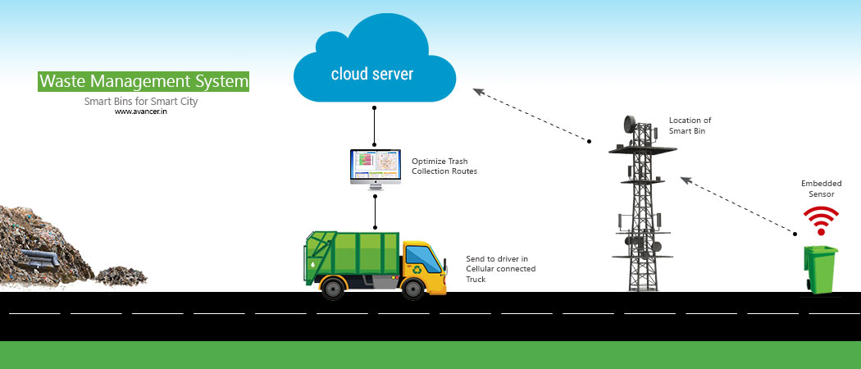

**K-Means:**

Another NP-Hard problem, it is especially complex when it comes to solving hard clustering problems. K-means is highly efficient method to be used as solution in situations of huge complex cluster parameters.

**Conclusion**:

The use of intelligent automation techniques in sorting the waste materials is highly feasible and time efficient. The Control systems have derived the knowledge of machine learning induction algorithms to enhance system adaptability. The preliminary sensor data from acoustic tests and light transmission have the potential to differentiate clear and unclear objects. Apart from this they possess the ability to wisely segregate glass, metal, and plastics using emitted sound waves. Electromagnetic sensors are to be implemented for preliminary metal sorting. Many companies have been establish with waste recycling robots that have revolutionized this field of machine learning.